Directions to ABB Inc.
Centennial Campus
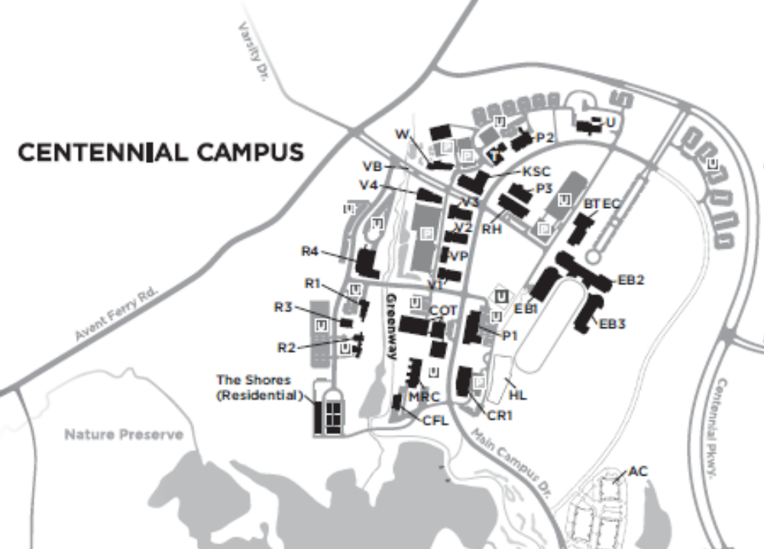

ABB Inc.
940 Main Campus Drive
Venture I Building
Raleigh, NC 27606-5200
From I-40 (coming east from airport): Take Gorman St. exit 295. Turn left onto Gorman St. Turn right at second light onto Avent Ferry Rd. (follow signs to Centennial Campus). Turn right at second light onto Varsity Dr. *There is a visitor information booth in the median. Stop there and get your visitor parking permit for ABB Venture I. Go past the visitor booth – turn right into the drive between the parking deck and the office buildings. Visitor parking is clearly marked. Coming out of Visitor parking, Venture I is the building to the far right.

From I-40 (coming west): Take Gorman St. exit 295 (follow signs to Centennial Campus). Turn right onto Gorman St. Turn right at second light onto Avent Ferry Rd. Turn right at first light onto Varsity Dr. and follow directions from above.

From Raleigh: Take Western Blvd to Avent Ferry Rd. Turn right onto Avent Ferry. Turn left at second light onto Varsity Dr. and follow directions from above.

